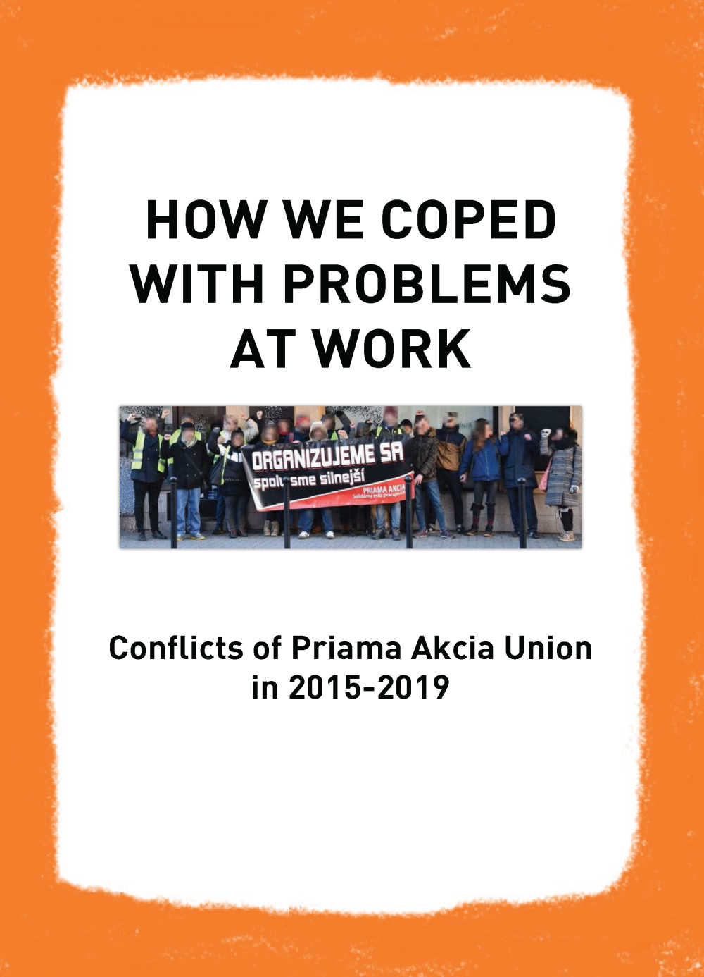

How We Coped with Problems at Work
Conflicts of Priama Akcia Union in 2015-2019

CONTENTS

Introduction

Conflict over unpaid remuneration with civic association Divé maky

Conflict over unpaid wages with CATO Agency

Three conflicts in the hospitality sector, many important lessons

General recommendations

INTRODUCTION

About ten years ago, we asked ourselves where we wanted to be as an organisation in the near future. At that time we were a small group whose main goal was to promote anarcho-syndicalist ideas. We didn’t call ourselves a union, and anarcho-syndicalism was something we weren’t able to push forward easily either since we were worried that we would scare people away.

Today, as we write these lines, we can think of no better term. In this introduction we will try to explain as briefly as possible how a small organisation promoting anarcho-syndicalism turned into an anarcho-syndicalist union (albeit still small).

The change was slow, gradual and based on practical experience rather than theoretical considerations.

From the random activities of a propaganda group
to the systematic activity of a workers’ union

Let’s start a little broadly. Priama Akcia was founded in 2000 and became a member section of the International Workers’ Association (IWA) in the same year. Thus, from the beginning, we advocated ideas drawn from the anarchist current in the labour movement. In the first years of our existence, we focused mainly on expressing solidarity with the struggles of workers in Slovakia, and organising solidarity actions with workers abroad. In addition, we published news and publications on labour-related issues.

We have always considered ourselves part of the working class and not some intellectual vanguard that is divorced from it. Even though in the early years the organisation was made up mostly of (working class) students, we were always looking for ways to put workplace activities at the forefront.

Our first experience with confronting superiors was gained while we worked as students. Later on, we tried to solve problems in the workplace which concerned our members, but also people outside the organisation. And although we didn’t proceed systematically, we gained a lot of experience and we clarified our future direction through practice.

Probably the biggest obstacle was the fact that we lacked a strategy, and thus our activities were mostly just responses to random events. So, we changed the things that weren’t working, agreed on clear principles and objectives, and launched our first campaign related to workers’ issues. We focused on what we already had experience with - student jobs. The campaign was called Are You Going to Work as a Student? and although it didn’t turn out as expected, it was a precursor to a much more successful campaign called Problems at Work?

It was this campaign that made it possible to start the first open conflicts with bosses, in which we were already able to present ourselves publicly as a union (and not just as individuals). So far, these conflicts haven’t been about setting up our own workplace unions, or about making bigger changes with a society-wide impact (although we believe those will come with time, too), but “only” about supporting workers when they were already out of their workplace. This pamphlet is an attempt to summarise these conflicts.

Conflict over unpaid remuneration
with civic association Divé maky

The first conflict we waged collectively as a union was a baptism by fire. It was the longest and the most difficult, and we organised the most protest activities so far. We experienced threats as well as criminal charges. Yet it brought us valuable experience for future conflicts and, most importantly, thanks to our perseverance and direct action tactics, we won.

THE CAUSE OF THE CONFLICT: UNPAID REMUNERATION

Civic association Divé maky (hereafter referred to as CADM) helps talented Roma children. It is financed by grants and donations from state institutions, companies and individuals. Michal worked in CADM as a freelancer, although in reality he was doing the work of an ordinary employee. After more than a year, he decided to find another job because he was no longer satisfied with the conditions in the organisation.

He had agreed with his boss, the managing partner of CADM, that he would leave on 31st July 2015. At the end of July, he received a document called the Contract Termination Agreement with her signature and confirmation that the parties had no outstanding financial or other claims against each other and would not make any such claims in the future. The only exception was the payment of the remuneration to Michal for the last month worked in the amount of €950.

However, the July money didn’t come, although Michal had written several times in August and September asking for it. Instead, the boss began to reproach him for allegedly unfulfilled work assignments and demanded various written explanations, despite the fact that two months earlier she had signed the aforementioned Agreement. Moreover, Michal initially volunteered to help with a number of things after leaving, while CADM wasn’t even able to provide him with necessary documents, even though he had requested them in writing.

So, it was obvious that the boss was stalling for time because she didn’t really want to pay him. Michal refused to accept that he would never get his money and contacted our union.

Although we reject racism and we are sympathetic to the concrete help CADM provided to Roma children, we couldn’t tolerate the non-payment of money for which Michal was contractually entitled to receive.

HOW WE AND THE OTHER PARTY PROCEEDED

Meeting with the worker

Michal knew that we only get involved in conflicts if the worker is involved in solving the problem. He took this precondition seriously and was very active and responsible throughout the preparation and duration of the conflict.

At the meeting he explained all the facts and background. There followed a discussion in the union about whether we could succeed in this conflict. The result was clear: we decided to support Michal. Together, we prepared a letter of demand, a plan to deliver it and we also thought about possible actions in case the money wasn’t paid.

In the letter, we defined the problem, demanded payment of the amount owed within 14 days and made it clear that we would be forced to take further action if the money wasn’t paid.

Delivery of a demand letter with a deadline

We wanted to deliver the demand letter directly into the hands of the boss. However, we knew that she didn’t come to the office every day. So, we came up with a trick. We contacted CADM posing as an enthusiastic potential donor and arranged a personal meeting on a specific day and time. In this way, we ensured the presence of the company head at work, and set off for the visit.

On October 28th, Michal rang the bell outside the association’s headquarters with a group of supporters. He was answered by a worker, to whom he announced that we had come to see the boss. He then briefly explained the reason for the visit, handed her the demand letter, reminded her of the deadline by which she had to pay the debt, and then we left.

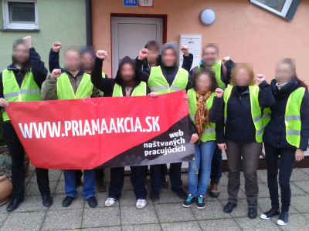

Open conflict and first actions
(and reactions)

We used the next two weeks to develop the strategy in more detail. In the event of non-compliance, we needed to be clear about what our actions would be in the coming weeks, in what order we would organise them, how we would divide the tasks, etc.

After the 14-day period had expired, we made a post on our website that we were entering a conflict to seek payment of the unlawfully withheld remuneration. The boss responded by giving power of attorney in the conflict to a lawyer who began to intimidate us with a lawsuit for posting information about the conflict.

This move rather amused us and had no impact on the prepared action plan. Legal formulations and threats of legal action are commonly used to intimidate workers. And they often work because people who aren’t very familiar with the law stop fighting for their demands, even if they are legitimate. Michal, however, didn’t give in.

We went on and published a template e-mail that people could send to CADM to express their views on the organisation’s actions:

I join the protest against the actions of the managing partner of CA Divé maky, Barbora Kohútik, who refuses to pay a contractually agreed and confirmed by her own signature remuneration of €950 to the former worker Michal R. I consider the managing partner directly responsible for the resolution of the situation. If the remuneration isn’t paid, I will inform as many people as possible about this case.

CA Divé maky, is it worth risking the reputation of your organisation and the fate of the children you support? Settle this conflict as soon as possible by paying for the work of your former worker who contributed to your goals. Running a charity doesn’t give you the right to put yourself in the position that you can do whatever you like with your contractual obligations.

I express my support for Michal R. and the campaign aimed at getting the outstanding remuneration paid.

We also translated this template into English and the CADM eventually received almost 150 protest e-mails (plus a few faxes), mainly from Slovakia, but also from 17 other countries (Austria, Brazil, Bulgaria, Canada, Croatia, Czech Republic, Finland, France, Germany, Norway, Poland, Portugal, Russia, Spain, Sweden, UK, USA), ten of which were from affiliated unions of the International Workers’ Association (IWA).

Information about the conflict had also spread on other websites and Facebook. People from the music scene showed their support as well: Oi Oi Piratoi, PKOTG, Rozpor, Železná kolóna and probably others. This simple form of support that doesn’t consume much time was an important part of the campaign. For almost two weeks, CADM received several protest e-mails a day. We knew that the e-mail campaign had raised concerns. It turned out that eventually it was one of the reasons for the payment of the owed money. But first things first.

Criminal complaint by the managing partner of CADM

The first attempt to file a criminal complaint came right after our visit. The boss used threats and extortion, but it was enough for us to check the relevant provisions of the law and it was clear that these accusations were ridiculous. Michal had no problem going to the police and giving an explanation. The first criminal complaint was very quickly reclassified as a misdemeanour and in the end even the misdemeanour procedure failed.

Saint Nicholas and the Devil get involved

After we published the article on our website and launched the e-mail campaign, an action on 6th December followed. Although Saint Nicholas and the Devil were busy, they managed to reward CADM. They left coal and a rhyme outside the door of its headquarters to make their point. ”This is outrageous! How can a charity dare not to pay the contractually agreed remuneration and what values does it teach children this way?”, they both commented. The rhyme read as follows:

St. Nicholas teamed up with the devil,
he won’t leave your debt alone.
Shame on you, Divé maky,
for your tricks and bluffs.

Divé maky - what are you?
Why have a contract with you?
The meaning of charity is lost
where work isn’t paid for.

It will get worse, Divé maky,
it’s not worth the money.
Those who don’t appreciate work,
Will only make it harder for themselves.

St. Nicholas teamed up with the devil
to speak to your heart on behalf of the children.
If you still have any,
you’ll transfer the usurped €950 to the account.

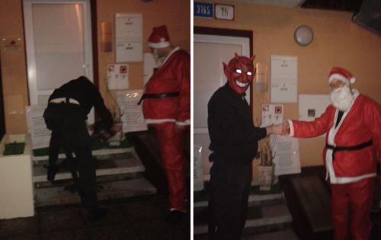

Out-of-court settlement proposal by CADM

In mid-December, the managing partner’s lawyer sent us a “last attempt at an out-of-court settlement” e-mail. We expected a concrete proposal, but instead it was full of bullshit about democratic principles of the state, legal tools for solving problems and dissatisfaction with the fact that Michal’s supporters have their faces anonymised in photos... After an introduction full of nonsense, Thor’s hammer blow came: Michal was alleged to have caused more than €3000 worth of damage to CADM (they claimed that everything was documented, of course). At the end of the e-mail, the lawyer emphasized that they have a mission to help others, which is why they were still willing to settle the whole problem out of court.

We were more or less amused (certainly more than less), although the idea of arguing with someone who, after almost half a year, was able to make up such lame accusations wasn’t appealing.

Well, we discussed all the accusations with Michal to see if he could refute each one. He could. Then we set about writing a response to the lawyer. Three days later, we sent him a list of actual legal violations by CADM with relevant sections of the law. Our response obviously caught him by surprise, because he didn’t reply.

The violations were wide-ranging, from the Criminal Code and the Commercial Code to the Labour Code. And they knew it well, as some of the violations had already been brought to their attention in November by the IWA Secretariat, which had been actively interested in the development of the situation from the very beginning.

We ask partners of CADM to give their opinion
(and we get a response from CADM)

We had counted on the stubborn attitude of CADM, so we proceeded to the next planned step: we started to reach out to CADM’s partners. Since the beginning of December, we had gradually informed people who directly or indirectly (often financially) supported the association’s activities about its practices, and always sent CADM a copy of the e-mail.

The reaction of CADM was peculiar. It was clear that we had hurt the association badly. Threats against Michal suddenly appeared on the Internet. The more comical part was that the managing partner’s lawyer officially boasted on a discussion forum on our website that CADM had really (and illegally) failed to pay the owed remuneration (“But since you were involved in a conflict with Michal ... we would like to inform you and the public about the reasons why Divé maky refuses to pay him the aforementioned remuneration for July 2015.”). He had no problem lying when he wrote that CADM has the full support of its partners (“Your activities with Priama Akcia have the opposite effect to what you probably imagined, as all the foundations you have contacted and also donors express their full support to us...”). And at the same time as these posts signed by him, almost identical posts (in content and style) appeared in the discussion, with absurd accusations of racism, insults addressed to Michal and his family, and threats of violence.

Here are some of the highlights:

“Your mother still doesn’t know what you’re doing?” (the post was followed by the name and permanent address of Michal’s mother)
”do you want to get that nose broken too ???? hmmmm”
“pathetic and primitive worthy of a loser”
“... are all of you so stupid ???? and it is said you are racists too”

The managing partner’s lawyer also didn’t hesitate to use the e-mail addresses of people who expressed support to further attack Michal. However, we had explained everything to the supporters in detail, and in the end it caused harm only to CADM.

Informing the public about the association’s practices
at Christmas market

Part of our strategy was to confront CADM in public. We considered it important to show the two faced-nature of the association and to inform people about its practices.

During the Christmas market on 18th December, CADM organised a cultural event at Hviezdoslavovo Square in Bratislava, where young Roma talents performed. We also came and handed out several dozen leaflets on the spot explaining the non-charitable side of CADM’s activities – the illegal non-payment of owed remuneration:

Do you like the activities of the civic association Divé maky?

Us, too. Unfortunately, not all. Maybe you don’t know about this one yet: for five months Divé maky have been refusing to pay a former worker the €950 remuneration for the month of July 2015 that they contractually agreed to, and have publicly admitted they are refusing to pay.

What happened?

It seems incredible to us, too, that civic association Divé maky, which has such a noble goal of supporting young Roma talents, could act this way. This is what happened: Former administrative worker Michal R. (by the way, ”employed“ not in the usual way, but as a freelancer) left Divé maky and in August 2015 he was waiting for his last remuneration to be paid. The money didn’t come, so he started to demand it, first on his own, and after several unsuccessful attempts, together with the solidarity union Priama Akcia. However, the civic association didn’t pay him his money, despite the documents submitted to prove Michal’s claim. As a result, the union entered a conflict with the association for payment of the owed remuneration.

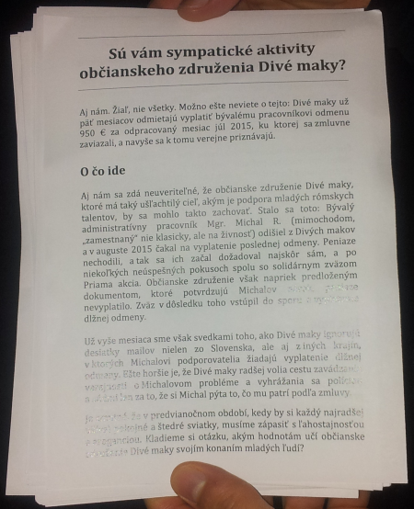
For over a month we have been witnessing Divé maky ignoring dozens of e-mails not only from Slovakia but also from other countries, in which Michal’s supporters are demanding payment of the owed remuneration. Even worse, Divé maky prefers to take the route of misleading the public about Michal’s problem and threatens Michal with the police and courts just because he asks for what is due to him according to his contract.

It is sad that in the run-up to Christmas, when everyone would most like to enjoy peaceful holidays, we have to contend with indifference and arrogance. We ask ourselves, what values does the civic association Divé maky teach young people by its actions?

What next, Divé maky?

We are sorry that we have to reach out to you as a result of this situation, and we are equally sorry that Divé maky, by their actions, are putting in an unenviable situation not only themselves, but also the talented children they provide financial support to. However, we believe that if someone works, they have to be paid and if they aren’t, it should always be pointed out.

The workers’ solidarity union Priama akcia will support Michal until he receives the owed money.

The longer the civic association Divé maky turns a blind eye to our legitimate demand, the more people will learn about their illegal actions. Keep your fingers crossed that it will take as little time as possible. If you don’t like what’s happening either, contact Divé maky. You can find our statement on our website at www.priamaakcia.sk, or if you have any further questions, we’d be happy to answer them and clear up any confusion.

Attempt by the IWA Secretariat to meet with CADM
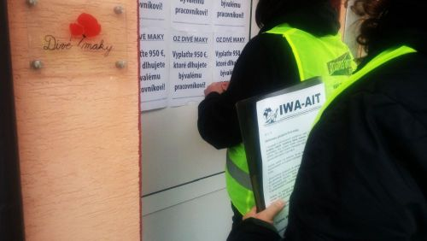
As we mentioned, the IWA Secretariat contacted CADM by e-mail in November and pointed out the strange practices of the association. At the end of December, members of the IWA Secretariat attempted to meet the boss in person. However, they couldn’t reach anyone in the office after the holidays, so they left their message in the mailbox and on the door. They also commented on the conflict in an interview, which captured well what was actually happening:

“We think it’s terrible that anyone has to experience something like this. Moreover, this organisation tries to justify its blatantly unethical practices by using even worse practices, such as making threats, reporting frivolous allegations to the police just because there are people who peacefully defend a worker, and writing letters to supporters blaming the situation on him. They are trying to justify something that is unjustifiable – the non-payment of €950.”

Association of Desperate Lawyers

In mid-January, Michal was contacted by a board member of CADM who was also the association’s lawyer (not the lawyer of the boss). He indicated a willingness to pay the owed money, but he first wanted to meet in person with Michal alone. The day after, he was surprised and displeased when a member of our union, passing off as Michal’s friend, showed up as well, but he realized rather quickly that he couldn’t do anything about it.

His tactics were fascinating. First, he admitted that our actions were causing huge problems for CADM, therefore we had to stop them immediately. But then he jumped back into intimidation mode. His attempt to cut a deal consisted of a “generous” offer to pay Michal half of the owed money and a perverse show of ”goodwill“ by promising not to sue him for embezzlement and mismanagement in the organisation. Michal refuted these desperate and false accusations long ago, and we had informed all supporters about them, too. While the lawyer presented new ”findings”, they were equally lame. Michal refuted several of them immediately at the meeting without even having to look at his documentation.

The meeting with the lawyer wasn’t pleasant, but Michal quickly shook it off. Together we discussed the whole thing and came to the only sensible conclusion – Michal couldn’t accept the offer because it was contrary to his demand and obligation under the Contract Termination Agreement. The next day we informed CADM that as a sign of our goodwill, we were suspending all our activities for five days from the moment the lawyer contacted us (13th January). We added that if CADM didn’t pay the whole owed money by 18th January, we would be forced to escalate the conflict.

The next phase of the campaign and payment of the owed amount

As expected, CADM didn’t pay the money within the given deadline. And so, on 20th January, we chose to inform one last partner of the CADM (again, with CADM in a copy) from the list of partners that we gathered, thus completing the first phase of contact. A second phase was to follow, which would have hit CADM even harder, but on the afternoon of 21st January, both the lawyer and the managing partner of the CADM wrote to Michal that the money had been paid. He received it in his account on 22nd January 2016, less than three months after he and our union had jointly requested it.

We acknowledged receipt of the money and ended the conflict over the unpaid remuneration. We also warned CADM that if they failed to comply with the entire Contract Termination Agreement, we were prepared to immediately enter a new conflict and take all necessary public, media and legal action.

MICHAL’S PERSPECTIVE ON THE CONFLICT

After the end of the conflict, we were interested in Michal’s impressions, what he went through and how the conflict affected him. It resulted in the following short interview:

What did this conflict teach you and how did it affect your life?

It gave me a lot. It confirmed to me that what I believed, namely that a collective action against the bosses is successful when it is conducted responsibly and sensibly. I am glad that we have succeeded. I don’t think I would have got the money, let alone the full amount, without the involvement of PA or a similar campaign. This conflict proved it very simply and directly. It taught me that such activities are always better dealt with collectively than alone.

What was the most important thing for you in the conflict?

The support from the IWA was a very positive thing. The IWA was involved not only in the form of sending e-mails and faxes. Members of the Secretariat personally visited the office of the association, although in the end they couldn’t meet anyone there. I think that by offering me financial support, they also left the impression that this is a serious cause. This support also calmed me down and gave me the confidence to persevere.

One of the most important things in this conflict was support in the form of sending protest e-mails, which really weighed in. I would like to thank everyone who got involved in the campaign, whether by sending e-mails, expressing support or actively helping. I very much appreciate that support and it has really helped in the course of the conflict.

What advice would you give to someone with a similar problem?

You definitely need to be calm and not let the bosses break you. Even if it’s someone you’ve known longer and wants to play with your emotions. Don’t back down, don’t react to their suggestions and do your own thing. Don’t be afraid of accusations or intimidation because the collective will back you up.

WHAT THE CONFLICT GAVE US AND LESSONS FOR THE FUTURE

Every conflict is a source of learning and improvement. We always try to talk and write about them publicly so that they benefit not only us but also other workers.

A deeper understanding of context

As we mentioned earlier, the conflict with the CADM was our first collectively led conflict. However, it was far from the first workplace issue we had dealt with. For example, we already had a pretty good knowledge of the issue of defamation thanks to lessons learned from previous cases. However, during the course of the conflict we also learned more about topics related to the treatment of personal data, liability for damages, the possibility of using commercial and civil law in conflicts, and the issue of “dependent work” (as defined in Slovak Labour Code).

Psychological aspects of a conflict

Experiencing a conflict, waging it and winning it brings such a range of impressions and feelings that it can’t be compared to anything we have experienced before. We have seen that we can succeed and help ourselves and other workers. And that means a lot, because that is one of the fundamental things that we do we do.

We came out of the conflict with boosted self-confidence. We have proven that our efforts and organising are yielding tangible results and are therefore worthwhile. For it is one thing to read about other people’s successful conflicts, but quite another when we win a conflict ourselves through our own efforts and the solidarity of others. We know now that what we do, we do well, and we are very likely to succeed.

However, the conflict brings with it other psychological aspects, too. Both the individual and the collective responsibility for the success of a conflict can easily cause unpleasant feelings, fears, anxiety and insecurity, sleeping problems, etc. In the long run, these are outweighed largely by positive effects, but it must be remembered that while one will have a lot of fun in a conflict, the actual organising of the conflict isn’t fun.

How can we manage conflicts as well as possible from a psychological point of view? Taking into account our other conflicts, we think a lot depends on the number of active people. The more people there are who share the tasks and take responsibility for completing them, the better the conflict can be handled emotionally and psychologically.

Evaluation and improvements

Closing a conflict doesn’t mean closing off the topic. The last stage is always the evaluation. All members of the union critically commented on various aspects of the conflict and reflected on what worked and what didn’t. Based on this, we came up with improvements for future conflicts and tips for other militant workers willing to stand up for their demands.

An example from this conflict could be the organisation of an e-mail campaign. It turned out that there was no point in sending protest e-mails or faxes on the very first day after the call had been published. Thus, we came up with a tactic of gradually spreading the published information about the conflict with the effect of regular pressure over a period of almost two weeks. In subsequent conflicts, we further refined this procedure and extended the period even more.

Evaluations can also be useful as sources for theoretical and practical texts, and the main ideas of this booklet draw are based on what we wrote after the conflicts.

Support

Most of the people who supported Michal at the demand letter delivery or leafleting were not from Priama Akcia. Neither were St. Nicholas and the Devil ;). The same is true of the conflicts that followed. Why do we mention it? We want to point out that even if there is a lingering reluctance in society to organise and pursue systematic activity, it is possible to succeed when an organisation has people around it who are willing to do the right thing.

While such situation is not our goal, we understand its causes. And we are constantly trying to demonstrate in practice that it makes sense to participate in e-mail campaigns, demand letter deliveries, pickets and other forms of direct action against companies. In other words, that it makes sense to get organised because it actually works. Everything is easier to prepare when people are part of the organisation.

Growth from a slightly different perspective

We mention the membership issue because people often wonder whether workers will join the union after a conflict. This hasn’t happened to us yet, but in most cases participants continue to support our union and get involved in further conflicts. Michal, for example, has willingly assisted other workers in different stages of their conflicts and shared his experiences. The fact that he knew us before the conflict and our ideas were close to his heart probably also played a role. The situation we’re in now, where people continue to support our union and our conflicts, makes us happy at the moment. We have never been an organisation that focuses on recruiting new members and it certainly isn’t a measure of success for us.

Potential of music scene, and of basically anyone

Solving problems at work is not an attractive topic and getting broader support in conflicts is always a challenge. Thanks to social media, the music scene has great potential for spreading the word about conflicts and contributing to resolving workplace related issues. In Michal’s case, people in the scene sent a number of protest e-mails, which helped a lot. Still, they got involved mainly because they knew Michal personally.

However, we all have acquaintances, and in conflicts it’s always important that people we know try to reach out to other people they know. After all, it is one thing to spread the word to hundreds or thousands of people on social media, and another to directly ask them to send an e-mail or come to a protest (and possibly reach out to other people who will do the same).

Power of the organisation

Our strength lies in direct action tactics and solidarity among workers. We are responsible to ourselves and to the workers and we are determined to fight until we win.

We are patient, resourceful and persistent in our communication with bosses. Thanks to organising and winning, we leave them a clear message that they need to think twice whether they want to continue their practices and experience our actions against their business or reputation in response.

Most of the time they count on the fact that if they screwed the workers once, they will get away with it again. But they usually don’t count on the possibility that an organised force will stand up against them. And certainly not that they will have to face direct action.

As a union, we are sending a clear message to workers and bosses that when a person decides to speak up and resolve a workplace conflict together with an organisation, direct action can achieve demands quite quickly (compared to lawsuits).

So, with all the experiences from Michal’s conflict, less than two months later we received a request from Martin.

Conflict over unpaid wages
with CATO Agency

Martin worked via CATO Agency from July 2015 to March 2016 for Royal Canin company in two branches of a construction and garden supplies store in Bratislava. Since November 2015 he also promoted products in another store. Although he received his first payments on time and in accordance with the provisions of his contract (and the Labour Code), further payments were regularly delayed. Although he was aware that it’s illegal, he didn’t know what to do in such a situation, so he resigned and simply waited for the money. Eventually, they always came. Until...

CAUSE OF THE CONFLICT - UNPAID WAGES

Martin wrote to us in mid-March 2016, when he learned that the managing partner of CATO Agency had accused him of causing more than €1,500 in damages. Two weeks later, he was told that representatives of Royal Canin and CATO Agency met and proposed a solution to the issue of damages (now, suddenly, raised to €3,000). Martin would work for free in April and May under the supervision of a representative of Royal Canin and they would be even. Of course, he was also told to say goodbye to the money he was owed for work performed in February and March.

Martin wrote back to the CATO Agency boss that he would think about it and get back to her. Together we agreed that the proposed solution was absurd and unlawful. We also discussed the accusation of causing damage, but we concluded that it was unfounded. We explained to Martin that a potential conflict would require his proactivity, and then we made a list of things that would have to be gathered and checked, so that we could come up with a plan to get the owed wages for February and March. We concluded that we needed to get more information, so Martin told the boss that he needed some more time. By doing so, he showed to her that if she wanted anything from him, it would be him who determined the time of response.

HOW WE AND THE OTHER PARTY PROCEEDED

At the next meeting with Martin on 19th March, we clarified the demands and discussed concrete steps. Martin was interested in entering the conflict, so we agreed that he would try to formulate the wording of the letter, which we would jointly deliver to the boss at the beginning of May at the company’s headquarters in Košice in Eastern Slovakia. We provided him with the wording used in the conflict with CADM for inspiration. We took over the coordination of the action in Košice and Martin prepared the demand letter. In the meantime, one of our members started to contact activists from Košice asking them if they would come and support Martin during the letter delivery.

A conflict that almost wasn’t

However, the start of the conflict wasn’t entirely smooth. Martin fell silent and contacted us again only five days before the planned letter delivery in Košice. We explained to him that if we were to enter the conflict, we expected a more responsible approach on his part and compliance with the agreements and tasks agreed to at the meetings.

Martin regretted the situation and suggested that we end our cooperation and not enter the conflict. Yet, we felt that the problem was more technical and perhaps we shouldn’t rely solely on internet communication, which wasn’t working reliably. Besides, we thought it would be a pity to if we allowed the company to get away with it. So, we proposed an alternative form of communication and asked him if he would change his mind about the conflict after all. It turned out that the problem was really related to the method of communication and we found a new solution. Eventually, Martin decided to enter the conflict.

We agreed to meet on 1st May in Košice and pay a visit to the boss’s new house on the outskirts of Košice. We had already explored the place and taken pictures so we knew where we were going and what to expect. This made it easier for us to figure out how we were going to proceed.

May Day in the spirit of the workers’ struggle

The plan to hand over the letter symbolically on May Day was a pleasant coincidence. On that day our union had a presentation in Košice, organised by activists from Food Not Bombs and the cultural space KLUB, where we spoke about our activities and the conflict with CADM. Before the presentation, we went with Martin and ten other people to deliver the demand letter to the official headquarters and, at the same time, the home of the boss and her husband, who were both the managing partners of CATO Agency.

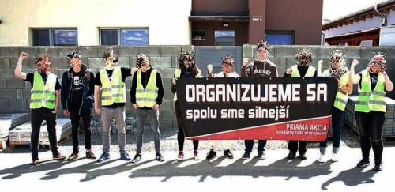

We didn’t reach anyone at home, so Martin left the letter in the letterbox and we took a photo and made a video of the whole event, just like in our previous conflict.

Getting ready

The boss was given seven days to pay the illegally withheld wages. In the meantime, we met with Martin again and discussed when to publish the first of two articles about the conflict on our website. Also, we prepared a timetable of the activities planned for May and June and agreed on the date of our next meeting. Accidentally, we decided to publish the article about the conflict on a symbolic date again, Friday the thirteenth.

Uncertainty over the amount owed

Since the boss didn’t pay the owed money, we published an article. Almost immediately, Martin was contacted by CATO Agency’s lawyer. Martin’s demand was that he was entitled to €350 for February and €35 for March. On the phone, the lawyer mentioned €390 for February. Right after the call Martin was contacted by the boss, who claimed that all the money had been paid, which wasn’t true.

Martin didn’t like the fact that the other party was using different amounts, so he checked his calculations again. In addition, the boss sent his breakdown of the hours worked for each month with their alleged dates of payment. The fact that she claimed she had paid Martin money for hours worked in March already in February certainly didn’t give us much confidence in her accounting...

After careful checking, it turned out that the amounts were actually a little different. The problem arose from late payment of wages and confusion over the amounts for each month. For February, the amount was not €350 or €390 (which was in fact a late payment for December 2015 and January 2016 which was paid only at the end of February 2016), but €155. So we sent our new calculation to the boss and pointed out the errors. She didn’t respond to our corrections. She only wrote to Martin that if he had any confusion about his wages, he should discuss it with her and not through our union. After these clarifications, as a matter of fairness, we corrected the owed amount on our website. The conflict continued.

Divide and conquer

But we needed to solve one more thing. Even though we had been communicating with the boss from our address since the beginning of the conflict, she had replied only to Martin. She obviously wanted to make it clear that she didn’t accept our participation in the conflict. The problem, however, was that Martin tended to reply to her messages. We didn’t blame him. We came across similar situations during the conflict with the CADM. Fortunately, in both cases we cleared things up fairly quickly and rationally and eventually all the communication with the other party went only via organisational e-mail.

The point is that from the moment we enter a conflict as a union, the union becomes the point of contact and not the individual. It is a disadvantage for the person in conflict to communicate from a personal address or telephone. The other party is then more likely to disrupt our joint steps, which could lead to ill-considered, hasty and rash responses, which could even cause isolation and a return to the original situation when that person faced the boss all alone.

We won’t rest

On 24th May the second article was published with a solidarity appeal in support of Martin (an English version was published a week later).

We created a template protest e-mail and anyone had the opportunity to express their opinion about the company’s practices using an online form:

I hereby express my disagreement with the fact that you haven’t paid your worker Martin a salary of €190 for the work he has done. I expect you to deal with the matter responsibly and to pay this amount promptly. Otherwise, I will inform other people about your company’s practices.

Let me also express my astonishment at your actions. Failure to pay wages is not only a criminal offence but also morally wrong. I believe that the sum of €190 isn’t liquidating for your company. On the contrary, it is a significant sum for Martin as a student and, moreover, it is money for work done, to which he is entitled under his contract with CATO Agency Ltd.

I express my support for Martin and the campaign for his unpaid wages. If necessary, I will also get involved in this campaign in other ways than just by e-mail.

We also invited people in and close to Košice to contact us if they wanted to support Martin in other ways, as we had other actions planned in the city.

The article appeared on several websites and Facebook pages. We also approached organisations from the International Workers’ Association (IWA) and received positive responses and support. As a result, the boss received at least one protest e-mail a day until 7th June (in total over 60 e-mails were sent, about half of which were from abroad).

The boss didn’t give up, and a few hours after the article was published, there were two reactions. The first went to Martin’s supporters. Since they had dared to send her a protest e-mail, she threatened them that if they published false information, they would be committing the criminal offence of defamation of a legal entity (and of course, the company would have to undergo legal action... because people sent e-mails...). However, there was no false information in our articles. We were already quite familiar with the issue of defamation from the past, and from the conflict with CADM. So, basically we just smiled faintly. We added a note to the article that if people get a response from the CATO Agency, they can forward it to us so that we can see if they are writing the same nonsense to everyone (and so that we can possibly respond to them).

The second reaction went to Martin. He received an e-mail without any word about the owed wages. The boss wanted to scare him as well, and again brought up the topic of alleged damages. She even forwarded him a communication with Royal Canin in which the amount of the damage was again different (no longer €1500 or €3000, but €1300 including VAT). In addition, she began to accuse him of failing to comply with the agreed to attendance policy. Martin immediately sent us his explanations. Some pieces of her information were completely untrue, other pieces were taken out of context and distorted. However, we were only interested in the payment of the outstanding wages. After all, they couldn’t simply not pay the wages on the basis of alleged damages. If a worker admits to the damages, the matter is decided by the court. Despite its threats, the company knew very well this wouldn’t succeed. Moreover, the law specifies exactly the amount of wages that can be deducted in case of damages.

Contacting company partners

We met with Martin again to discuss the next course of action, in which we wanted to use previously undisclosed information about company practices. We were not planning to rest. On the contrary, we wanted to push harder. We found out that the boss is responsible for the PR and marketing of Art Film Fest in Košice, which was about to start in June. So, at the end of May we started to approach the festival organisers asking them to comment on their cooperation with a person who doesn’t pay wages.

The boss’s reaction came the same day. However, she only forwarded her last e-mail to Martin, and added a note that she wanted him to contact someone from our union, because, allegedly, she was referring the matter to a lawyer. This absurd logic amused us again. Two days later, an e-mail was sent to another festival partner, and then to another and another...

Direct action at the fashion show

In addition, we agreed to organise a protest action during the Art Film Fest costume show on 1st June. Martin was supposed to take part in the event, but unfortunately his work commitments got in the way at the last minute and he was unable to travel to Košice. It wasn’t an ideal situation, but we decided to go for it anyway.

The fashion show took place in the renowned Jasmín Hotel. Activists from Košice arrived in front of the hotel with a leaflet about the conflict and talked to visitors of the event, advertising partners and media about the actions of the person responsible for the PR of the festival. The remaining leaflets ended up behind car wipers in the parking lot of the hotel.

Text of the leaflet:

PR and marketing of Art Film Fest in the hands of a person that owes wages

Yes, there are still many entrepreneurs in Slovakia who refuse to pay wages. Among such companies is CATO Agency Ltd, whose managing partner Veronika Šmihuľová Kašpar is also responsible for PR and marketing of Art Film Fest.

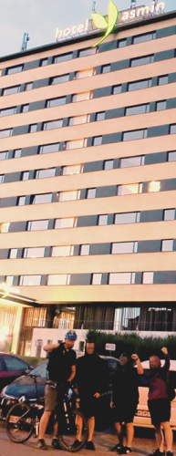
This flyer isn’t directed against Art Film Fest. However, we believe that when it comes to non-payment of wages, it’s never right to remain silent. We strongly hope that you agree with us, too, as people who appreciate the arts, which have always been a means of pointing out societal ills.

What happened?

Mrs Šmihuľová Kašpar unlawfully refuses to pay worker Martin a salary of €190 for the work he did for CATO Agency Ltd in February and March 2016. This obligation arises from the Temporary Student Work Agreement concluded on 16th July 2015, which states: ”Wages are payable in arrears for a monthly period, no later than the end of the following calendar month, in accordance with Section 129 of the Labour Code.”

But Martin still doesn’t have his money. We believe that the amount of €190 cannot be liquidating for any company, but for Martin as a student it is a considerable amount. He did his work and he did it in accordance with the contract.

It’s sad that on the day of the press conference and fashion show we have to point out such a serious problem. However, we wonder what guarantee there is that Mrs Šmihuľová Kašpar won’t act illegally in her other activities, as she hasn’t yet resolved Martin’s case and the money remains unpaid?
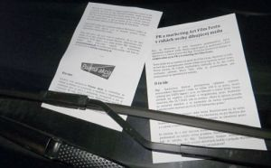
We are sorry that we have to reach out to you as a result of this situation, and we are equally sorry that Mrs Šmihuľová Kašpar by her actions puts not only herself, but also Art Film Fest in an unenviable position. However, we believe that if someone works, they have to be paid and if they aren’t, it should always be pointed out, even though in this case it may not be good for the PR and marketing of Art Film Fest.

This leaflet has been produced as a sign of support for Martin in the hope that CATO Agency Ltd will finally take a responsible approach and pay the wages owed.

Keep your fingers crossed that the conflict lasts as short a time as possible. If you don’t like what’s going on either, please support Martin. We also recommend contacting CATO Agency Ltd or Mrs Šmihulová Kašpar directly. Our position can be found on the website www.priamaakcia.sk. If you have any further questions, we will be happy to answer them at info@priamaakcia.sk.

And the money was suddenly found

In the end we didn’t have to carry out other planned activities. Exactly one week after the fashion show, Martin received €175 to his account. We agreed that we would write to the boss, objecting that it wasn’t the full amount. She didn’t want to reimburse Martin for a taxi (€5), despite her initial promise, as well as for the two hours (€10) he had worked on a promotional event for Royal Canin (the request to stay at the event for two more hours came on the spot from the responsible representative of this company). So, we sent an e-mail to the boss mentioning these facts and were curious to see what attitude she would take.

She responded the next day, but there was no clear answer regarding the €15, so we reminded her again. Only then did the boss make herself clear. She sulkily wrote back that she didn’t consider our union to be Martin’s representative and would only keep contact with him. And she added the obligatory threat of legal action.

She informed Martin that he didn’t provide the original of the receipt for taxi (the scan he had sent wasn’t enough) and that she wouldn’t pay him for the two extra hours he had worked, because she had never asked him to do anything like that. (It would be quite interesting to see the accounting between CATO Agency and Royal Canin and how the two hours were accounted for therein...).

Martin said that it wasn’t worth it to argue with her for €15. We respected his decision and considered the conflict closed.

Pay attention to CATO Agency practices

In an article we published after the conflict, we summarised the ambiguity surrounding CATO Agency’s practices to warn people who might want to work for the company in the future:

- Late payment of wages
The company paid the wages after the time limit regulated by Section 129 of the Labour Code.

- Non-payment of wages
This was the cause of our conflict. Moreover, the boss initially lied and said that she had paid everything. We’re convinced that Martin only got his wages thanks to our campaign.

- Record keeping of hours worked
The company had difficulty providing complete records. However, Martin kept good records of e-mails and text messages and this also made it easier for him to challenge the records provided by the boss.

- Contract in breach of legal requirements
The students’ temporary work agreement didn’t properly specify the job description or the place of work. There were also inconsistencies in the dates in the contract, which the boss probably noticed later as well. She asked Martin to sign a document that would partially address this. We experienced a similar attempt in our previous conflict (who knows why bosses try such transparent tricks...).

- Is CATO Agency Ltd a work agency?
The company has ”agency“ in its name, but according to the Commercial Register it had nothing in its scope of activity that would entitle it to provide workers to other companies. Yet, Martin worked for another company (Royal Canin) on the premises of a third company (the construction and garden supplies store) and carried out work not only according to instructions from the managing partner of CATO Agency but also according to the Royal Canin representative.

In the article, we also warned students to be careful when signing contracts and doing work for different companies and referred them to our freely available publication on temporary student work that contains workers experiences and legal context.

MARTIN’S VIEW ON THE CONFLICT

During one of our meetings Martin mentioned that he has known our association for some time and had even been to one of our presentations. So, we didn’t have to explain to him how we work, we only asked him to read what we published about the conflict with CADM, so that he would have an idea of what he can expect. As it turned out, he eventually found himself in similar situations as Michal, and he also handled them well. He also talked to Michal in person at one of the meetings.

After the conflict, we were curious again about how the worker himself perceived it, and asked him the same questions as in the CADM case.

What did this conflict teach you and how did it affect your life?

It convinced me of the power of direct action as a form of struggle. In my case it was for my wages, but I think I can generalise and say that various social problems can be solved by similar forms of pressure. Without Priama Akcia, I cannot imagine that I would have succeeded so quickly in the conflict, or at all. Also, the conflict helped me to learn how to deal with different situations without getting nervy; I mean, I really haven’t encountered anything like it before.

What was the most important thing for you in the conflict?

It was the support of the people. I knew I wasn’t alone in this. When we delivered the demand letter in Košice, I didn’t expect that there would be so many people willing to selflessly support me. I also felt the support of friends and acquaintances, but it was more or less only moral.

What advice would you give to someone with a similar problem?

I would advise anyone with a similar problem not to worry. I realise that sometimes it is easier to overlook injustice, even if it is directed at you personally. I know that people are generally afraid to stand up to those who are in a superior, more powerful position. I myself debated for a long time whether it was worth it to enter an open conflict, but the support I felt throughout it and the successful outcome convinced me that I had made the right decision.

WHAT THE CONFLICT GAVE US AND LESSONS FOR THE FUTURE

Each of our conflicts is different. Although we use the same tactic (direct action), each time we have to take into account completely different circumstances and develop a strategy that will ensure that the workers’ demands are met as quickly as possible.

Gathering experience for further struggles

From the beginning, we assumed that after each conflict we would be better off because we would be able to utilise previous experience. In this case, we managed to fulfill that to the letter. We were able to provide Martin with moral support in more tense situations and explain our proposals well in situations that were similar to past ones. We stressed the importance of not getting drawn into pointless debates, not surrendering, focusing on the facts, putting aside the urge to explain things to bosses (which is useless) and simply ‘doing it our way’.

We believe that if we want to bring about change in society, people need to organise. In organisations we gather experiences from our own struggles and struggles of other people. If our work is systematic, it better prepares us for critical social situations, but also for dealing with the day-to-day problems of our members and other people who ask for help. The ability to solve these problems is then a signal to other workers that they are not alone and together we can do something. When we asked Martin in the beginning why he turned to us, his answer confirmed what we had just written: he thought that thanks to our experience we would be able to advise him. In the end, we were not only able to advise him, but also to help him solve the whole problem.

Coordinating a conflict in a city without a local group

This conflict was a major challenge for us. We had to consider whether we dared to take it on because the root cause was related to Košice, which is 400 km from our local group in Bratislava. Although we had members in the region (so-called isolated members who are a full part of the union but too few to form their own local group), taking care of a conflict when one is alone in a city and when one is in a group are very different. We made sure that if we helped each other and shared the responsibilities, we could manage the conflict.

Activists from Košice helped us a lot. They participated in organising and took on two important direct actions: the demand letter delivery and the protest in front of the hotel. In other words, they played a key role in the conflict. In general, there was a good response from people in Eastern Slovakia in terms of the number of protest e-mails sent.

Unexpected events

We were unpleasantly surprised that Martin’s documentation for calculating the owed amount wasn’t entirely accurate, so we had to correct it. A similar thing happened to us later in another conflict (that we won) in the hospitality sector. The reasons were the same in both cases: messy accounting, late payment of wages and the bosses unwillingness to communicate before the conflict. Thus, avoidable ambiguities could only be resolved once the companies saw that we were serious. This experience tested our ability to react to unforeseen situations, resolve them appropriately, and succeed in conflicts in spite of them.

We have compiled the other three conflicts in a different way compared to the conflict with CADM and CATO Agency because they relate to the same industry, hospitality. We tried to capture the first two conflicts in detail, and provide their chronology and anatomy. In the following conflicts we look into the context of the industry and its specifics.

Three conflicts in the hospitality sector

Between 2017 and 2019, we had three conflicts in the hospitality sector. They concerned a pizzeria, a café and a bistro. We were successful in two within a matter of weeks, while the third one was prematurely terminated by a worker. Although we’re speaking only about three conflicts, we think they can be meaningfully compared and evaluated. Also, we supplemented our analysis with some tips that might be useful not only for people working in the hospitality sector, but in others as well.

THE CAUSES OF CONFLICTS

We have reported on the causes of these conflicts in separate articles on our website, so we will only briefly summarise them.

* Martin worked at Lozano Pub as a pizza maker and the company refused to pay him €201 he was entitled to for the holidays he took.

* Mia was a waitress at Space Mania café (a playful café for children and adults) and the owner owed her €222,44 for the hours she worked.

* Jakub worked as an assistant cook in a bistro and the boss failed to pay him his wages and compensation of €584,61.

WORKERS’ FIRST STEPS

Both Martin and Jakub first tried to solve their problems individually. Martin was met with what might be called a tactic of repeated promises. When he asked for the money he was owed, he kept hearing that he would get it, but nothing happened. Although this tactic often causes a person to lose interest in solving the problem, Martin didn’t give up and contacted us (even after the response from the Labour Inspectorate that they wouldn’t deal with the matter and he should take it to court).

Jakub also communicated with his boss frequently and responded to her intention to dismiss him by trying to negotiate better conditions. Her response was much harsher than in Martin’s case. We would call it simply revenge (although to describe it as hurt ego wouldn’t be far from the truth either). She threatened to assign him fewer shifts, which she eventually did. It got to the point where she refused to pay him all the money owed.

In Mia’s case, the situation was more complicated. When she came to the café for her last paycheck, her boss gave her only part of the money (€70) for the 20 days she had worked, claiming that it was the amount for the 40 hours that she worked, and refused to show her attendance card. Mia was given a “choice“: either she must sign a copy of a pay slip or her boss wouldn’t even give her the €70. Mia signed it and immediately called her friend Maja, to whom she confided with everything. They then tried to contact the boss by phone, SMS and later by e-mail, but without any response. The boss gave us the cold shoulder, but that tactic didn’t lead the worker to resign. On the contrary, Mia responded admirably. Together with Maja and sometimes also other people, they started protesting with banners outside the café several times a week. The boss used a play the victim tactic from her arsenal: each time she called the police, to whom she then explained that Mia had been stealing from them, that the children in the café were scared, or that the protests were disturbing public order. After several weeks of actions with no result, Mia and Maja contacted us asking for help.

INVOLVEMENT OF PRIAMA AKCIA UNION
AND THE FORMULATION OF DEMANDS

In these conflicts, too, we took the same first step. We studied all available documents and, where necessary, calculated how much the boss actually owed. This procedure is designed to determine the exact amount that will later be included in the demands.

Martin’s case was relatively clear. The amount owed was based on information from the company’s accountant.

Mia was instructed by her boss to mark fewer hours than she actually worked, but fortunately she kept her own records. She also took a photo of her actual attendance book, thanks to which we finally calculated the exact amount owed.

Jakub’s case required the most complicated calculation. His boss paid part of his salary illegally without any pay slip or receipt, so the existing pay slips were one big mess, the employment contract did not contain mandatory requirements such as working hours, and his boss stopped assigning him shifts. In the end, however, we did manage to write down an exact demand.

It should be added that Martin and Jakub also marked and made photos of the documentation of hours worked. They also saved their pay slips and had important texts or other messages available. Such documentation makes it much easier to prepare for a conflict because we can formulate demands more easily and apply pressure more effectively. But we do not say that all is lost if such documentation is missing. We just want to emphasise how important it is to keep a record of everything that happens in the workplace (and it doesn’t have to be related only to money, but also to working conditions, health and safety at work, etc.).

DEMAND LETTER DELIVERY

Demand letter delivery is an action by which we let the company know that the workers have a problem that has to be solved, and that our union stands by them. The letter always includes a deadline by which the solution is due. If the company fails to meet it, we enter an open conflict. During the deliveries, the responsible persons acted very differently.

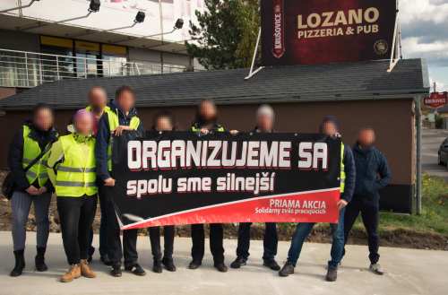

The head of the Lozano Pub acted like a sovereign. Very quickly he began to try if he could separate Martin from the rest of us (he tried to persuade him to sit down at the table and talk with him without us). Fortunately, thanks to our presence, the boss didn’t manage to break Martin.

In the case of Space Mania, we caught the boss’s husband (who occasionally works at the café) outside the café’s entrance. He followed his wife and gave us the cold shoulder, too, pretending that the problem didn’t concern him at all, and refused to take the letter. After asking him if we should leave the letter on the ground outside Space Mania’s door, he phlegmatically indicated that we’re free to do it. And so we did. After we left (and returned to check a few moments later), he had to bend down to pick it up and hand it to his wife. She suddenly came to life, stopped ignoring Mia and texted her asking to “reach an agreement”. However, instead of a concrete agreement, all she really wanted was for Mia to meet with four(!) Space Mania lawyers. She wanted them to deal with the whole issue and free herself from any responsibility.

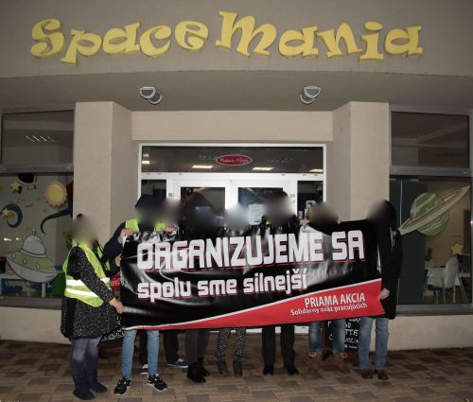

We didn’t manage to reach Jakub’s boss in person either, but we exchanged at least a few e-mails. Since she was the only one who paid the money on the due date, we didn’t start an open conflict.

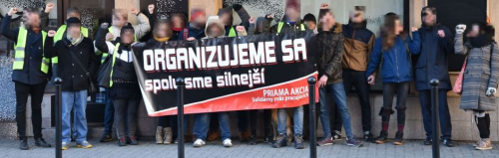

ESCALATION OF PRESSURE

We started classically, with media coverage. We posted basic information about company practices on our website, calling for solidarity with the workers. People could call the company, express their opinion by e-mail or add a few words on rating portals.

The second step was concrete pressure actions.

At the time we entered into conflicts with Lozano Pub and Space Mania they both were about to host third-party events (a stand-up comic show and a children’s event). We took this opportunity to inform the third parties about the conflict. We explained that they could contribute to bringing it to a swift end and avoid problems that would arise if they worked with the company during the conflict.

In the case of the owner of the Lozano Pub, the response was lightning fast. Who knows why he chose to respond on a Facebook page of Czech Anarchist Federation, where he wrote the following under our article about the conflict which the AF shared:

“So, to put things right. Former employee Martin hadn’t contacted me once in the last year until he visited the restaurant last week with the lot in the photo. They surrounded my table while I was dining, which I think is absolutely impolite and unmannered. And their insolence was so great that they started filming me having lunch with a camera. When I suggested to Martin to stay, so that I can see what he had to say, one of the insolent and unmannered ones said to him no, you’re coming with us. If you think that this insolent behavior of yours applies to me, you are mistaken, maybe it applies to Japanese whaling boats. The former employee has my number, knows where to find me and can talk to me about his problem, and if I find out our company owes him something I’ll see that it’s sorted out. And I’ll give you one piece of advice, live so that you don’t have to blur your faces in photos.”

We responded:

“On multiple occasions during 2017, Martin informed Lozano Pub that his holiday went unpaid. We have text messages containing repeated promises that the money would be paid. To date, this has not happened.

On 30th October you were again informed of the problem and received a written demand to settle the debt. Since then, two weeks have passed, during which you could have resolved the problem and paid the owed €201.

The only solution in this conflict is an immediate payment of the owed amount to Martin. Once the amount for the holiday (which is the sole cause of this conflict) is paid, we will consider the conflict closed.”

Three days after the conflict began (or the very next day after the communication on Facebook), the owed money was paid.

The conflict with the bistro ended even earlier and didn’t even get to the stage of open public conflict, as the boss sent the money to the account before the deadline.

So, the real escalation of pressure only happened in the case of Space Mania. There we even got a reaction from a third party. The owner of FUNTASIA, which is an agency that was working with Space Mania on an event called “Frozen Party”, wrote back to us when we brought the problem to her attention, saying that Space Mania’s practices were not her concern and that she would not comment on the whole matter. We were not going to accept such alibism and we decided to visit Frozen Party.

First, in the centre of Senec (a town close to Bratislava where Space Mania is located), we handed out leaflets explaining the conflict and how people can show support. Reactions were favourable, many people already knew about the problem and were shocked that such a thing was happening. Some even promised to spread the word among their friends or to approach the owner of the company herself.

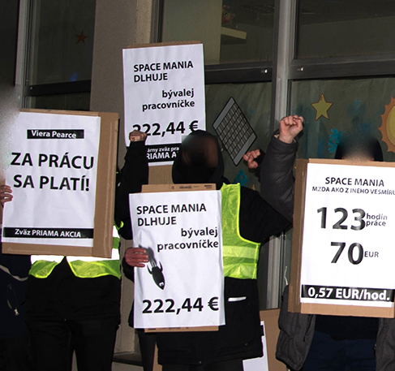
Upon arriving inside the Space Mania premises, our favourite guy (the owner’s husband) started shouting at us and pushing one of us. We reacted calmly: we handed out flyers to the parents and looked for the owner since we wanted her to tell us when she would pay the owed money. The owner’s husband, on the other hand, made a fuss and urged the worker behind the counter to call the police, which we found highly inappropriate given the presence of children (especially if the police had actually come). We stayed for a few more minutes and then left the premises. Additionally, we contacted the parents via Facebook and made it clear that our intention was not to spoil the event for them or their children. We are parents ourselves and we explained that we think it is unacceptable for people like this to work with children and run a business that doesn’t pay wages.

The action in Senec was not the only pressure activity. The owner received dozens of e-mails from Slovakia and abroad. Mainly the organisations (and their members) were from the International Workers’ Association (IWA) in Austria, Norway, Poland, Russia, Spain, UK and USA. The IWA Secretariat sent an e-mail, and support for Mia also came from individuals and other friendly organisations from Czech Republic, Croatia, Germany, Slovenia, Spain, UK and USA. A number of people also expressed their opinion on Space Mania’s Facebook page (the posts were repeatedly deleted).

We returned to Senec once more for the Pirate Party event. We armed ourselves with pirate masks, a drum, banners, we were loud and heard. The owner of the café wasn’t present again, and our favourite guy had been replaced by a hire from a private security company. He didn’t bother us, because he was inside almost all the time. However, we still didn’t leave the boss alone. After about half an hour we moved in front of her apartment block, where we continued chanting. This event was particularly successful because even though there were a few parents with kids inside, the event as such actually didn’t happen.



We didn’t carry out the other planned activities because a few days after we agreed on a plan of further actions with Mia, she started to seek an end to the conflict with her boss without telling us. As this was a breach of our agreement to proceed together, we had to inform Mia that we were suspending activities from our side. A week later Mia informed us that she was ending the conflict. In the end, she didn’t receive the money she was owed.

RESULTS AND WORKERS’ OPINIONS

Martin got exactly what he asked for. The amount of €201 was transferred to his account. He later wrote to us:

It took a lot of effort, but it was well worth it, for which I am very grateful.

Mia didn’t get her money, but she (as well as Maja) wrote us the following:

Mia:
“I don’t want to deal with it anymore. We went there for half a year and it didn’t go anywhere, but I would like to thank all of you who were helping me. I won’t forget that you helped me. Once again, a big THANK YOU.”
Maja:
”Thank you Priama Akcia for taking up this conflict on my initiative. I really appreciate it, I have learned a lot of new things and I hope there will be an opportunity for me to help you more.”

Jakub expressed his impressions in a more extensive interview.

Why did you decide to solve the problem at work with our union?

I have known Priama Akcia for at least five years and have always supported it because I sympathise with its activities. I believe that mutual aid and solidarity is what can help people fight the injustices arising in today’s system. Another reason was that it was a long shot to address anything with the boss even when she claimed to be willing to address the matter. I knew I couldn’t accomplish anything on my own, so instead I contacted PA.

Many people may find it strange or even suspicious that you didn’t take legal action to resolve the problem. Have you met with opinions? What do you think about it?

I didn’t talk much about the bistro problem to people around me, and to those who knew about it, I explained in advance why I thought it was better to resolve it with Priama Akcia rather than through the courts, and also what the disadvantages were of resolving such issues through the courts. The primary issue is time, the conflict gets dragged for long and just makes you sick. Especially with regard to the Slovak judiciary.

One of our conditions was that you would be proactive and that we wouldn’t do things for you. Could you say if there was any difference between your idea of being active yourself at the beginning and what it involved in the end, for example in terms of time and the need to respond to the development of the matter?

Knowing how PA conflict resolution works, there was no difference between my perception and the reality. Of course, preparing for a conflict and dealing with the details doesn’t mean that I ask for something, PA does it for me and I don’t have to care about it anymore, so all this takes up quite a bit of time and requires a lot of detailed work and patience. But if we want to achieve something in society, we have to work TOGETHER. :)

What was the most difficult thing for you during the problem-solving process?

The most difficult was how time-consuming these activities were. It was not extreme, but given the fact that I have scheduled activities and responsibilities from morning to evening almost every day, it was sometimes quite difficult to fit in the activities related to problem solving.

How did you feel about asking for money for hours you didn’t work?

At first I wasn’t even planning on asking for it, but when I learned from Priama Akcia people that it was possible (and backed up by the law), I agreed with it. It felt strange at first, but then I remembered my boss’s statement that she would determine how much I would work, which seemed to me already then as a rip-off.

How did you feel about the collective demand letter delivery in the bistro? What was encouraging or, on the contrary, stressful for you?

The nervousness was there, of course, but I don’t know why I should be afraid to ask for what is rightfully mine. The encouraging moment was the support from the people who came with me to deliver the letter. I really appreciated it and I was pleased to see that people can show solidarity and not just close themselves into their world of egoism. Another positive moment was that I saw my colleagues again. :)
The stressful moment, apart from the delivery itself, was handing it to the restaurant manager, with whom I have a good relationship, and I didn’t want her to take it as a personal attack. On the other hand, I believe that she understood what was going on.

We know that at some point the owner adopted a typical employer tactic: she started to intimidate and threatened to a file criminal complaint, which is always unpleasant. How did you feel about that? What advice would you give to other workers in such situation?

It wasn’t pleasant, but I expected it. Filing criminal complaints is a common tactic of employers in conflicts with PA. From what I know, they were always fabrications with no merit. In my case this was doubly true as the campaign hadn’t even started yet. In the end, despite the threats, the boss didn’t file any criminal complaint.
I would advise other workers not to worry, because as long as they are asking for what is theirs, they are certainly not acting illegally.

How did you react when your boss sent you more money than you asked for (or what did you think about it)?

She announced it in her last e-mail. I was surprised, but only believed it when the amount arrived. But for me it wasn’t about gaining more from the bistro (where, by the way, the colleagues I like continue to work, and I didn’t and don’t want it to have any negative impact on them), so I returned the “surplus” right away.

And how did you feel about the fact that she sent you more?

She pretended that it was an act of kindness and generosity on her part, but in the context of the whole e-mail, I felt as if she had put me in the position of a little poor man who ”can’t even afford a coat“, as the saying goes. I’m not a charity case. I was only asking for what was owed to me.

What advice would you give to someone with a similar problem?

I would advise, and not only to someone with a similar problem, but to anyone who has or had problems at work to address them and not accept injustice from bosses or management. In the hospitality sector, and in other industries as well, employees should come first because they make the profit. The bosses should get used to a situation that they can’t take liberties with employees and do whatever they want.

CONFLICTS IN NUMBERS

 | Lozano Pub | Space Mania | bistro
Length of conflict (from the demand letter delivery) in days | 14 | 63 | 19
Number of solidarity e-mails sent (that we are aware of) | 4 | 58 | 0
Amount owed (in €) | 201 | 222,44 | 584,61
Amount won (in €) | 201 | 0 | 584,61

WHY DID WE SUCCEED IN TWO CONFLICTS AND FAIL IN ONE?

Success depends primarily on adherence to the agreed strategy. The reasons for non-compliance with the agreement in the Space Mania case may well appear in other conflicts and can probably never be entirely avoided. They are mainly related to doubts on the part of the workers arising, for example, from questions like these:

“Is the conflict really going to be resolved, if there is no visible progress even after weeks of activities?”

Looking at things from a time perspective is understandable. A conflict can last several months and eventually end in success. For example, our conflict with OZ Divé Maky lasted 86 days and ended with the payment of the owed €950.

It is also interesting to see when the companies capitulate. On several occasions we saw that it happened shortly after they had expressed strongly that they would not back down under any circumstances. So, it is worth sticking to the direct action strategy, which simply works.

“Are the demands backed by sufficiently convincing evidence?”

It’s different when one starts a conflict over an amount of money confirmed by the company itself (the conflict with Lozano Pub) and when the company starts by claiming that the amount is unreasonable (the conflict with both Space Mania and the bistro). Even when people know that the truth is on their side, over time doubts may emerge. They sink into negative considerations and feel as if they are standing before a court of law and have to have bulletproof evidence of their truth, even though in some cases it’s more about ”word against word“.

Although we base our conflicts on documentation that would succeed in court, in a direct action strategy one needs to think differently. This is because it’s the workers (and not the courts) who determine what is a legitimate and just demand. And it’s the workers who will win it through their own activity, not by relying on someone else.

In addition to factors that are more subjective or psychological, market competition can also play an important role. More specifically, how the business owners perceive the competition. They attach varying degrees of importance to their image, which may be reflected in their stubbornness or willingness to surrender and hence the length of the conflict.

The Lozano Pub hosted third-party events and they knew these could move elsewhere in case of problems, not to mention the fact that people could use other dining options in the area. The bistro was in a similar position, as there were plenty of competing establishments in the area as well.

On the contrary, Space Mania was basically the only place of its kind in Senec at the time of the conflict. Even if cooperation with third parties was cancelled, the parents would have no other option. So, while in the pizzeria and bistro the threat of long-term financial loss worked quite quickly, in this case the boss could tell herself that major profit problems wouldn’t arise so soon because people with young children would always end up at Space Mania anyway. However, the café wasn’t very profitable and it was likely that sooner or later the boss would have no choice but to pay the owed money as a result of repeated protests.

HOSPITALITY – A LOT OF PROBLEMS, BUT ALSO A WILLINGNESS TO FIGHT

Hospitality is characterised by a strong push to save on wages and thus on labour. Of course, there are many industries like this. However, in our experience, it’s in hospitality that we encountered problems most often. At the same time, it was the sector with the highest number of people who were determined to fight back.

However, these were people who were no longer employed by these companies or about to leave them. If they were still there and planned to stay, the organising would look different, but that’s a situation that we have yet to experience.

Workers we dealt with were at the same time looking for another job so that they could quickly resolve the loss of income, or they had already found one. They had to set aside time for planning and activities, and count on possible stress. Despite this, they didn’t give up and stood up to management, which is a positive sign that even when people are in a bad situation, they can be proactive and fight back successfully.

As for the characteristics and typical problems in this sector, we have looked at them more closely and written them down. We don’t consider the following list to be exhaustive and would be happy if you could help us and add other points, so that we can improve it (especially if you work in hospitality).

General points

- Low wages and thus relatively low amounts owed
At first sight, it might seem that for the workers it’s not ”worth“ fighting for the owed wages. The opposite is true. We are aware of conflicts over large sums of money (for example in other countries), but we also had conflicts that were around €200. We believe that people were willing to fight for these relatively small sums because they knew about our previous conflicts and they could clearly see that we could succeed.

- High turnover
While this factor doesn’t affect the final decision on whether we start a conflict with a company in the hospitality sector, if the worker is no longer working there, that will make organising more complicated. Yet it’s difficult everywhere. If turnover means layoffs, then firing someone (legally or illegally) is possible everywhere. Still, finding a full-time replacement quickly is a difficult, and many companies in hospitality are aware of this.

- A simple structure of social relationships in the workplace
There is usually a boss/owner, a manager and the workers. The relationships that arise in this triangle usually turn against the workers in the form of emotional or social pressure. This pressure, resulting from distorted ‘friendship’ relationships with management, is sometimes so strong that it can have a negative impact on workers even when they are no longer working in the company. If there are no people in the workplace to stand up to this “friendly” emotional blackmail or outright intimidation, the whole collective suffers.

Points related to the employment relationship and pay rate

- Low awareness of legal rights and obligations of both workers and companies
When it comes to companies, it may seem like they’re just playing dumb, but that’s not always the case. Sometimes they really don’t know what they’re talking about. As for the workers, it’s always good to know the law. Not knowing what I’m entitled to can mean not addressing the problem. There are many websites on the Internet that provide valuable legal advice in an easy to understand form. While relying solely on them even in a case when you are willing to start a conflict isn’t the best solution, they certainly can raise your understanding of the legal context of the situation in the workplace from the legal perspective.

- Frequent occurrence of invalid or incomplete employment contracts
Again, this may be due to the amateurism of companies, but it may also be intentional. For example, omitting one of the essential or regular elements of the employment contract can have a negative impact on working or pay conditions. We wrote about this in more detail after the bistro conflict ended in an article from March 2019 called ”Unpaid wages and wage compensation - what can you do about it?” (in Slovak only).

- Incorrect or no pay slips
We covered this topic in the above-mentioned article, too. In short – the payslip is another official document and proof of how much money you’re getting. It can be compared with the details in the contract and the actual time worked. Any discrepancies can be used against the company in the event of a conflict.

- Unclear records of hours worked
Yes, time is money, and if you don’t keep track of how much you’re working, you don’t know if you’re getting paid properly. If the number of hours you work on paper is less than the hours you actually work, the company can screw you and pay you less at any time. The documentary evidence will be on the company’s side, and while it doesn’t mean there’s no chance to fight for the owed money, it involves more complications.

- Working for minimum wage with additional money paid ”in hand“, sometimes without documentation at all
In such a scenario it’s difficult to prove and enforce the actual owed wages. Another problem is that the boss decides how much you get according to his or her own discretion, the current needs of the company or his or her mood. It may be the same amount for a long time, but there’s no guarantee that it will be the same amount next month, or that you’ll get it at all.

- Level of difficulty of the work
It’s not common to talk about the difficulty level of the work, but it’s key, especially for people making minimum wage. There are six levels. For people working on so-called Work Agreements, the minimum wage is determined on the basis of the first level (from 1st January 2020 it’s €580 gross per month). For the others, the level is determined by the type of work and the employee’s work tasks. You should always check that the company has classified you correctly.

- Unpaid work or so-called ”trials“
Companies often combine this tactic with contract signing delays. People sometimes work ”for free“ for several days, and if not paid, they would rather leave than deal with it.

Occupational Health and Safety (OHS)

- OHS provisions can be a powerful motivator in the struggle to improve working conditions. In the hospitality sector, it’s common to work shifts (often more than 8 hours), to work overtime, to work evenings, weekends and public holidays, and to be flexible in filling in for colleagues. These factors can interfere with work-life balance and cause increased stress.

- The work itself is often demanding both physically (long periods of standing) and mentally (dealing with people). Moreover, companies have no problem violating OHS, for example when it comes to mandatory breaks or time off. A topic of its own is (non-)compliance with hygiene regulations.

STATISTICS

The Statistical Office defines the following as activities related to hospitality (restaurants and pubs): restaurant and mobile food selling, food delivery and other services, and hospitality services. When we speak of the hospitality sector, we refer to those activities.

The number of people employed in the hospitality sector has been rising in recent years, and at the time of the brochure’s publication (winter 2020), nearly 50, 000 people were working in hospitality.

The average wage in hospitality is close to the minimum wage. Data for 2018 and 2019 show that it increased slightly over each year, but only reached or moved slightly above the minimum wage in the second half of both years. The data in the table capture average gross pay, not reduced by statutory or employee-agreed deductions (business income is not included). The minimum wage was €480 in 2018 and €520 in 2019. The quarters in which the average wage was lower than the minimum could be explained by part-time work. However, it’s evident that official wages in this sector are extremely low.

 | 2018 | 2019
Q1 | 459 | 496
Q2 | 461 | 519
Q3 | 477 | 526
Q4 | 494 | at the time of publication no data

GENERAL RECOMMENDATIONS

Based on recurring issues we have had to deal with during conflicts inside and outside the hospitality sector, we wrote a short list of recommendations. By following them workers may stand better chance of succeeding when addressing workplace related problems.

• Mark your actual and work-related time accurately: hours worked, weekend and holiday work, doctor’s appointments or care for a family member, holidays, sick leave... In the case of holidays and sick leave, it’s sufficient to keep track of days, of course. In other cases, minutes are also important.

• Always try to have all information related to work and wages in writing.

• Keep all documents related to money. Archive your e-mails, texts or other communications with management.

• Get a payslip. Always ask for it and don’t take no for an answer. If something doesn’t make sense, ask for clarification. There may be accidental mistakes in your payslip, but there may also be deliberate accounting practices behind them that are worth checking to see if they’re doing any harm to you.

• If you are paid illegally, for example, if you receive money in envelopes with anything written on it (the amount of money, for example), keep them. If you’re signing something, try to make it evidence (for instance by taking a photo). And while you may be comfortable with being paid illegally, it’s always worth thinking about how you could make it a legitimate income. For example, your chances of getting a mortgage depend on your official income, and so does the amount of social benefits you receive, including sick pay, holiday pay, maternity pay and pension.

• We recommend taking the information about the well-being of the company that comes from management (especially if they say they’re not doing well) with a grain of salt. They share information with the intention of having things their way. Don’t forget that they have their business plans and ideas about the development of the company, and their goal is to make money. In other words, to get the most of you for the least amount of money. They give you the impression that you’re in the same boat, but you probably know very well that this is not the case.

• If something is bothering you at work, check the Labour Code, the Occupational Health and Safety Code or other sources for more information.
In conclusion, we would like to encourage everyone who works, whether within hospitality or not, to address their workplace problems and not give up, even though the situation may seem intractable. It’s not a good idea to rely on the Labour Inspectorate or the courts, or to let people walk over you. You can solve problems at work by your own activity.

And if you had a workplace experience similar to ours, let us know about it. We’d be happy to publish it to give courage and inspiration to other workers.

How We Coped With Problems At Work
Conflicts of Priama Akcia union in 2015-2019

Priama Akcia union was involved in five conflicts in 2015-2019. All but one have turned out in favour of the workers involved. The key thing was that the conflicts were under their control all the time and followed direct action tactics. In practice, we have shown that anarcho-syndicalist principles work and produce results. We are delighted to share with you these first successful anarcho-syndicalist activities in Slovakia, and hope that they inspire other workers.

Conflict over unpaid remuneration with civic association Divé maky (Bratislava)

Our first conflict was over unpaid remuneration to a self-employed worker. It was the longest and the most difficult, and we organised the most protest activities so far. We experienced threats as well as criminal charges. Yet it brought us valuable experience for future conflicts.

Conflict over unpaid wages with CATO Agency (Košice)

In addition to the problem of unpaid wages, the temporary worker was accused of damages and the boss demanded that he pay part of it by working for free. In the end, he won his money and didn’t have to pay for any damages.

Three conflicts in the hospitality sector
Lozano Pub (Bratislava), Space Mania (Senec), bistro (Bratislava)

All involved owed money. We succeeded in two of them within a few weeks, while the third was prematurely terminated by a worker. Also, we supplemented our analysis with some tips that might be useful not only for people working in the hospitality sector, but in others as well.

How We Coped With Problems At Work
Conflicts of Priama Akcia union in 2015-2019
First Slovak edition: Nakladateľstvo bod zlomu (February 2020)
First English edition: Nakladateľstvo Bod Zlomu (October 2021)

